PBM, Inc.  1070 Sandy Hill Road  Irwin, PA 15642  724-863-0550 | PBM Valve Application Data Sheet | 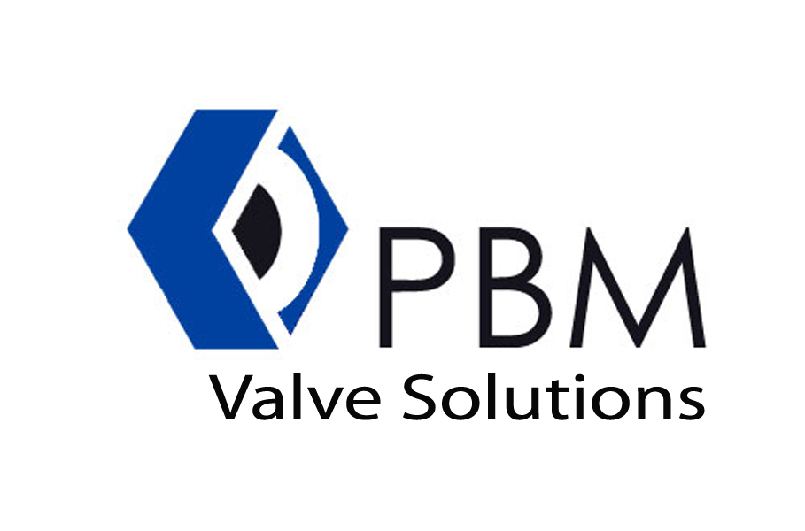

GENERAL INFORMATION
Is this for export? | Yes | End User |  | Date
If yes, complete screening document |  | Project |  | Data Sheet
- see page 3 |  | P.O. |  | Specification
Is a CRN required? |  | Site |  | Quantity
If so, province: |  | Tag(s) |  | Drawing
Is this destined for the EU Community? |  |  | If so, what CE / PED certificate / marking is required ?

MEDIA
1 | SERVICE CONDITIONS |  | Units | Max | Norm | Min | Shut-off
2 | SERVICE CONDITIONS | Media |  |  |  |  | Bubble-tight
3 | SERVICE CONDITIONS | Flow Rate |  |  |  |  | Class IV
4 | SERVICE CONDITIONS | Inlet Pressure |  |  |  |  | Class V
5 | SERVICE CONDITIONS | Outlet Pressure |  |  |  |  | Class VI
6 | SERVICE CONDITIONS | Design Pressure
7 | SERVICE CONDITIONS | Operating Temperature
8 | SERVICE CONDITIONS | Design Temperature
9 | SERVICE CONDITIONS | Spec Wt / Spec Grav / Mol Wt
10 | SERVICE CONDITIONS | Viscosity / Solids
11 | SERVICE CONDITIONS | Allowable / Predicted SPL
12 | SERVICE CONDITIONS | Line Flushing / Cleaning Media / Gas

13 | VALVE BODY & BALL | Schedule |  | Line Size | Inlet |  | 53 | ACTUATOR | Pneumatic | Electric
14 | VALVE BODY & BALL | Pipe Tube |  |  | Outlet |  | 54 | ACTUATOR | Mfr & Model | PBM | Other
15 | VALVE BODY & BALL | Line Insulation |  | Yes | No |  | 55 | ACTUATOR | Size |  | Eff Area
16 | VALVE BODY & BALL | Type |  |  |  |  | 56 | ACTUATOR | On / Off |  | Modulating | Yes
17 | VALVE BODY & BALL | Size |  |  |  |  | 57 | ACTUATOR | Fail Position
18 | VALVE BODY & BALL | Port Size & Type |  |  |  |  | 58 | ACTUATOR | Maximum Allowable Pressure
19 | VALVE BODY & BALL | PBM Model Number |  |  |  |  | 59 | ACTUATOR | Minimum Allowable Pressure
20 | VALVE BODY & BALL | Body & Trim Material |  |  |  |  | 60 | ACTUATOR | Available Air Supply Pressure
21 | VALVE BODY & BALL | Inlet Connection |  |  |  |  | 61 | ACTUATOR | Maximum |  | Minimum
22 | VALVE BODY & BALL | Outlet Connection |  |  |  |  | 62 | ACTUATOR | Bench Range
23 | VALVE BODY & BALL | Flange Face Finish |  |  |  |  | 63 | ACTUATOR | Actuator Operation
24 | VALVE BODY & BALL | Ra Polish |  |  | EP | Yes | 64 | ACTUATOR | Operator Type | Locking Lever | Lever | Oval
25 | VALVE BODY & BALL | If 3-way, 4-way or 5-way |  | Flow Pattern (see page 2) |  | # | 65 | ACTUATOR |  | Locking Oval | Gear Op
26 | VALVE BODY & BALL | Fail Position |  | A | B |  | 66 | ACTUATOR | Coating required? | Yes | No
27 | VALVE BODY & BALL |  |  | C | D |  | 67 | INPUT SIGNAL
28 | VALVE BODY & BALL |  |  |  |  |  | 68 | L.S. / POSIT | Type
29 | VALVE BODY & BALL | Ball Configuration |  |  |  |  | 69 | L.S. / POSIT | Mfg & Model
30 | VALVE BODY & BALL | Coating Requirements |  |  |  |  | 70 | L.S. / POSIT | On increasing signal, output |  | Inc | Dec
31 | VALVE BODY & BALL |  |  |  |  |  | 71 | L.S. / POSIT | Gauges |  | By-Pass
32 | TRIM | Type |  |  |  |  | 72 | L.S. / POSIT | Contact Rating
33 | TRIM | V-Ball or Slotted Ball |  |  |  |  | 73 | L.S. / POSIT | Enclosure Type
34 | TRIM | Characteristic |  |  |  |  | 74 | SOLENOID | Mfg & Model
35 | TRIM |  |  |  |  |  | 75 | SOLENOID | Voltage
36 | TRIM | Rated C_{v} |  | F_{L} | X_{T} |  | 76 | SOLENOID | Rating
37 | TRIM | Ball |  |  |  |  | 77 | SOLENOID
38 | TRIM | Seat Material |  |  |  |  | 78 | SOLENOID
39 | TRIM | Stem Material |  |  |  |  | 79 | AIRSET | Mfg & Model
40 | TRIM | NACE Required |  | Yes | No |  | 80 | AIRSET | Set Pressure
41 | TRIM |  |  |  |  |  | 81 | AIRSET | Filter |  | Yes | No
42 | TRIM |  |  |  |  |  | 82 | AIRSET | Notes:
43 | Other Requirements (API, CE, CSA, FM, Low-E, SIL-3, etc.) |  |  |  |  |  | 83 | TESTING | Hydro Pressure
44 | SPECIAL REQUESTS |  |  |  |  |  | 84 | TESTING | ANSI / FCI Leakage Class
45 | SPECIAL REQUESTS |  |  |  |  |  | 85 | TESTING | Other
46 | SPECIAL REQUESTS |  |  |  |  |  | 86 | TESTING | Other
47 | SPECIAL REQUESTS |  |  |  |  |  | REV # |  | DATE | REVISE DATE | ORIG DATE | APPROVED
48 | SPECIAL REQUESTS
49 | SPECIAL REQUESTS
50 | SPECIAL REQUESTS
51 | SPECIAL REQUESTS
52 | SPECIAL REQUESTS
ADDITIONAL COMMENTS

FLOW PATTERNS | DP ● 3-way ● SIDE ENTRY |  |  |  | DP ● 3-way ● BOTTOM ENTRY
Code (#) | 03 | 04 | 06 | 10 | 14 | 15 | 16 | 17 | 18
Port Style | T-90° | T-90° | T-180° | L-90° | L-360° | L-180° | T-90° | TT-180° | LL-90°
Position A

Position B

Position C

Position D

 | MP ● 3-way ● SIDE ENTRY
Code (#) | 01 | 02 | 03 | 04 | 05 | 06 | 07 | 08 | 09 | 10 | 11 | 12 | 13
Port Style | T-90° | T-90° | T-90° | T-90° | T-180° | T-180° | T-180° | T-180° | T-360° | L-90° | L-180° | L-180° | L-360°
Position A

Position B

Position C

Position D

MP ● 3-way ● BOTTOM ENTRY
For more information on PBM’s flow patterns, please see our Industrial, Sanitary Brochures or visit us on the web!

www.pbmvalve.com
Code (#) | 14 | 15 | 16 | 17 | 18 | 19  The flow diagrams depicted are a birds-eye-view - as though you are looking down on the stem. White areas indicate the path available for process flow. Shaded areas indicate unused ports for a given flow position.
Port Style | L-360° | L-180° | T-90° | TT-180° | LL-90° | L-90°
Position A

Position B

Position C

Position D

 | MP ● 4-way ● BOTTOM ENTRY
Code (#) | 20 | 21 | 22 | 23 | 24 | 25 | 26 | 27 | 28 | 29 | 30 | 31 | 32
Port Style | LL-90° | LL-180° | LL-180° | LL-180° | LL-180° | LL-360° | L-360° | T-90° | TT-180° | TT-180° | TT-180° | TT-180° | TT-360°
Position A

Position B

Position C

Position D

 | MP ● 4-way ● BOTTOM ENTRY |  |  |  | MP ● 4-way ● SIDE ENTRY
Code (#) | 33 | 34 | 35 | 36 | 37 | 38 | 39 | 40 | 41 | 42 | 43
Port Style | TT-90° | TT-90° | TT-90° | TT-90° | LL-90° | L-180° | L-360° | T-180° | ─90° | T-90° | T-90°
Position A

Position B

Position C

Position D

 |  | MULTI-PORT ● 5-way ● BOTTOM ENTRY
 | Code (#) | 44 | 45 |  | 46 | 47 | 48 | 49 | 50 | 51 |  | 52
 | Port Style | L-360° | LL-180° |  | T-90° | TT-90° | TT-90° | TT-180° | TT-360° | LL-360° |  | Y-120°
 | Position A  Position B  Position C  Position D |  |  |  |  |  |  |  |  |  |  |   
PBM, Inc.  1070 Sandy Hill Road  Irwin, PA 15642  724-863-0550 |  |  |  | Order / Quote Screening Form

  A. Bill To (Company Purchasing this Equipment)
  Buyer Name
  Company Name
  Address line 1
  Address line 2
  City / Postal code
  Country
  B. Ship To (Consignee) Same as Block A
  Contact Name
  Company Name
  Address line 1
  Address line 2
  City / Postal Code
  Country

  C. Ultimate Destination (End User) Country:
  Note: If End Dest. Country = USA, sections D, E and application info not req.
  If NOT USA, entire form MUST be completed.

  D. Ultimate Consignee Same as Block A Same as Block B
  Company Name
  Address line 1
  Address line 2
  City / Postal Code
  Country
  E. End User Same as Block A Same as Block B Same as Block D
  Company Name
  Address line 1
  Address line 2
  City / Postal Code
  Country
End-Use Standard Industry Codes (SIC)
Please check one as appropriate
2800 Chemical (except 2830 Pharmaceutical) | 2000 Food & Beverage (includes Tobacco) | Natural Gas & Refining
2600 Pulp & Paper  2800 Chemical Process OEM  2810 Industrial Inorganic Chemicals (not gases)  2813 Industrial Gases  2820 Plastic Material & Synthetics  2840 Soap Cleaners & Toilet Goods  2850 Paints & Allied Products  2860 Industrial Organic Chemicals  2870 Agricultural Chemicals (Including Fertilizer)  2890 Misc. Chemical Products  3000 Mfg. Rubbers & Plastics  3860 Mfg. Photographic Equipment & Supplies | 2010 Meat Processing  2020 Dairy  2030 Canned/Frozen foods  2040 Grain Products  2050 Bakery Products  2060 Sugar/Confection  2070 Fats & Oils  2080 Beverages  2090 Misc. Food Products  2100 Tobacco  3556 Mfg. Food Machinery | 2900 Petroleum Refining  3856 CNG  4920 Nat Gas Commerical, Utilization & Indus.  4922 Natural Gas Transmission  4924 Natural Gas Distribution  4925 LPG
 |  | Petroleum
1300 Oil & Gas Extraction
1310 Crude Oil Production
1380 Oil & Gas Field Services
2900 Petroleum Refining
4612 Crude Oil Distribution
4613 Refined Distribution
Others
1000 Mining of Metals/Non-Metals  2200 Textiles  2400 Wood Products, n.e.c.  2770 Printing & Publishing  2830 Pharmaceutical  2831 Biotech  2869 Alternative Fuels  2950 Asphalt  3220 Glass & Glassware, pressed or blown  3300 Primary Metals & Fabrication  3460 Metal Forgings & Stamplings | 3491 Industrial Valves  3530 Construction, Mining & Materials handling  3540 Metalworking Machinery & Equipment  3565 Packing & Crating  3670 Electronics & Semiconductors  3700 Transportation Equipment  3710 Motor Vehicles & Motor Vehicle Equipment  3720 Aircraft & Parts  3730 Marine  3740 Railroad Equipment | 3800 Instrument Manufacturers  4910 Power (excluding Natural Gas)  4911 Electric services  4912 Nuclear Power  4940 Water & Waste Treatment  5000 Resellers  8220 Universities  9199 Government  9900 Non-electrical Machinery  9999 Other - Please specify:

Application Information
End Use: | Biological Chemical Military Missile Nuclear Other
What does the End-User manufacture in general?
Specific End Product being manufactured with this equipment:
Process fluid/s (be specific)
Is "Heavy Water" a by-product of production? |  | Yes No

Test for suspicion/red flags: Is the transaction suspicious? Yes No
If “Yes”, give reason:
Authorization
Person completing this form For office use only
Name: |  |  | Reviewed by:
Company Name: |  |  | Date:
City: |  |  | Result:
State or Province: |  |  | Okay
Country: |  |  | Needs clarification
Phone: |  |  | Fail

